DR. BRUZZICHESI’S PATIENT REWARD PROGRAM!!
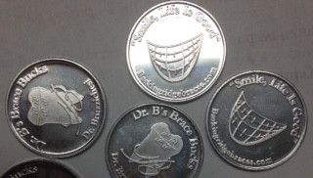
GOT BRACE BUCKS?
THE WAYS TO EARN YOUR BRACE BUCKS:
- GOOD ORAL HYGIENE

- BEING ON TIME FOR YOUR APPOINTMENT

- GOOD COOPERATION/WEARING YOUR ELASTICS

- WEARING YOUR TYE DYE SHIRT TO YOUR APPOINTMENT!
- “LIKING” US ON FACEBOOK

- PARTICIPATING IN ARE FUN CONTESTS THROUGHOUT THE YEAR!

THE GOODS:
REDEEM YOUR COINS FOR AN AWESOME PRIZE FROM OUR PRIZE CABINET!
- ITUNES GIFTCARDS
- CHIPOTLE GIFTCARDS
- HEADPHONES
- AND MORE!!
